1. **Table and Summary (see the footer)**

| Number | 1 | 2 | 3 | 4 | 5 | 6 | 7 | 8 | 9 | 10 |
| --- | --- | --- | --- | --- | --- | --- | --- | --- | --- | --- |
| Age | 72 | 69 | 87 | 57 | 13 | 79 | 79 | 43 | 92 | 72 |
| Sex | Male | Male | Male | Female | Male | Female | Female | Male | Male | Male |
| Date Born | 05. 30. 1947 | 08. 01. 1947 | 10. 12. 1921 | 05. 15. 1962 | 06. 18. 2004 | 02. 02. 1937 | 05. 12. 1940 | 10. 20. 1975 | 08. 09. 1923 | 05. 05. 1931 |
| Date Died | 06. 08. 2019 | 07. 24. 2016 | 10. 31. 2008 | 06. 06. 2019 | 12. 29. 2017 | 02. 14. 2016 | 05. 26. 2019 | 01. 13. 2018 | 06. 15. 2015 | 03. 24. 2003 |

| Number | 11 | 12 | 13 | 14 | 15 | 16 | 17 | 18 | 19 | 20 |
| --- | --- | --- | --- | --- | --- | --- | --- | --- | --- | --- |
| Age | 87 | 40 | 32 | 90 | 69 | 60 | 0 | 73 | 81 | 80 |
| Sex | Female | Male | Male | Female | Male | Female | Male | Male | Male | Female |
| Date Born | 11. 13. 1933 | 12. 25. 1979 | 09. 27. 1986 | 09. 29. 1929 | 06. 06. 1950 | 08. 18. 1948 | 02. 12. 2024 | 12. 14. 1937 | 12. 14. 1937 | 10. 28. 1938 |
| Date Died | 05. 16. 2020 | 05. 10. 2019 | 08. 20. 2018 | 04. 20. 2019 | 01. 16. 2019 | 11. 30. 2008 | 02. 13. 2024 | 07. 10. 2018 | 07. 10. 2018 | 04. 23. 2018 |

| Number | 21 | 22 | 23 | 24 | 25 | 26 | 27 | 28 | 29 | 30 |
| --- | --- | --- | --- | --- | --- | --- | --- | --- | --- | --- |
| Age | 39 | 64 | 82 | 76 | 74 | 60 | 79 | 41 | 2 | 52 |
| Sex | Female | Male | Male | Female | Male | Male | Female | Male | Male | Male |
| Date Born | 05. 19. 1970 | 12. 12. 1960 | 03. 25. 1936 | 07. 10. 1942 | 11. 17. 1938 | 06. 25. 1966 | 12. 12. 1932 | 01. 04. 1979 | 05. 22. 2018 | 04. 10. 1972 |
| Date Died | 07. 18. 2009 | 01. 01. 2024 | 07. 13. 2018 | 04. 17. 2018 | 09. 30. 2012 | 01. 05. 2024 | 06. 26. 2011 | 11. 14. 2020 | 03. 07. 2020 | 01. 01. 2024 |

**II. Analysis and Interpretation**

Based on my analysis and interpretation, most of the death respondents are seniors while some of them are middle aged and younger, not just young. They were born today and then died the next day. Which is sad to know and heartbreaking to the parents. I just want to clarify that this is just an equivocal interpretation of data that I've collected in the cemetery. I found some of the ruins that also may have caused their death and this rant about my relatives it's a fact. Without a doubt.

Either way, they were in a road accident. Just like what I've witnessed to my cousin from my father's side when I was young. Died right in front of the cemetery. I was traumatized by it. He just crossed the street. Whilst, I didn’t because I'm afraid to get mugged by a vehicle. May he rest in peace, eternally and who were buried there. A disease, like my aunt's breast cancer case. It was unexpected to know that even a healthy individual may suddenly have an almost normal appearance as it seems. Being poisoned like my uncle he drank a banana root extract on his birthday like I drank a portion of it too, my mom and my grandma. Mistakenly known as water though it isn't. Then, he died after a consecutive week. He's basically bipolar, anyway. So my grandma too, she's generous and loving, died because of her aging. I miss her, but I don't want to go with her in the afterlife today or the next future years. Then, the boss of my auntie’s died also three days after my grandma's burial. Death works in mysterious and unexpected ways.

What could possibly go wrong with their deaths in a peculiar scenario? Bedridden, choked up to their deaths, an overdose of a drug user or a hit and run case. Rivaling about the land title, or worse rape or killing your relatives. A betrayal sort of something that could happen. In a province, in mountainous areas, the cases are most likely stabs of bolo knives. Is it too much? No, I am just getting started. Recently, the most unnerving news is that they're brothers and the cause of their fight is guess what, in a drinking session. Maybe, there could be a miscommunication or have an argument or simply have a dubious hatred.

But mostly, in my data analysis, they are old and live their lives well. It's a sign of their aging, I think. There are also middle aged, the possibility of their deaths having a disease. Younger ones could be a terrible accident in different circumstances and then an infant could be a premature birth or maybe in normal figure, just unfortunate. The note in the footer serves as the summary according to my gathered information in the table in the previous page.

**III. Documentation**

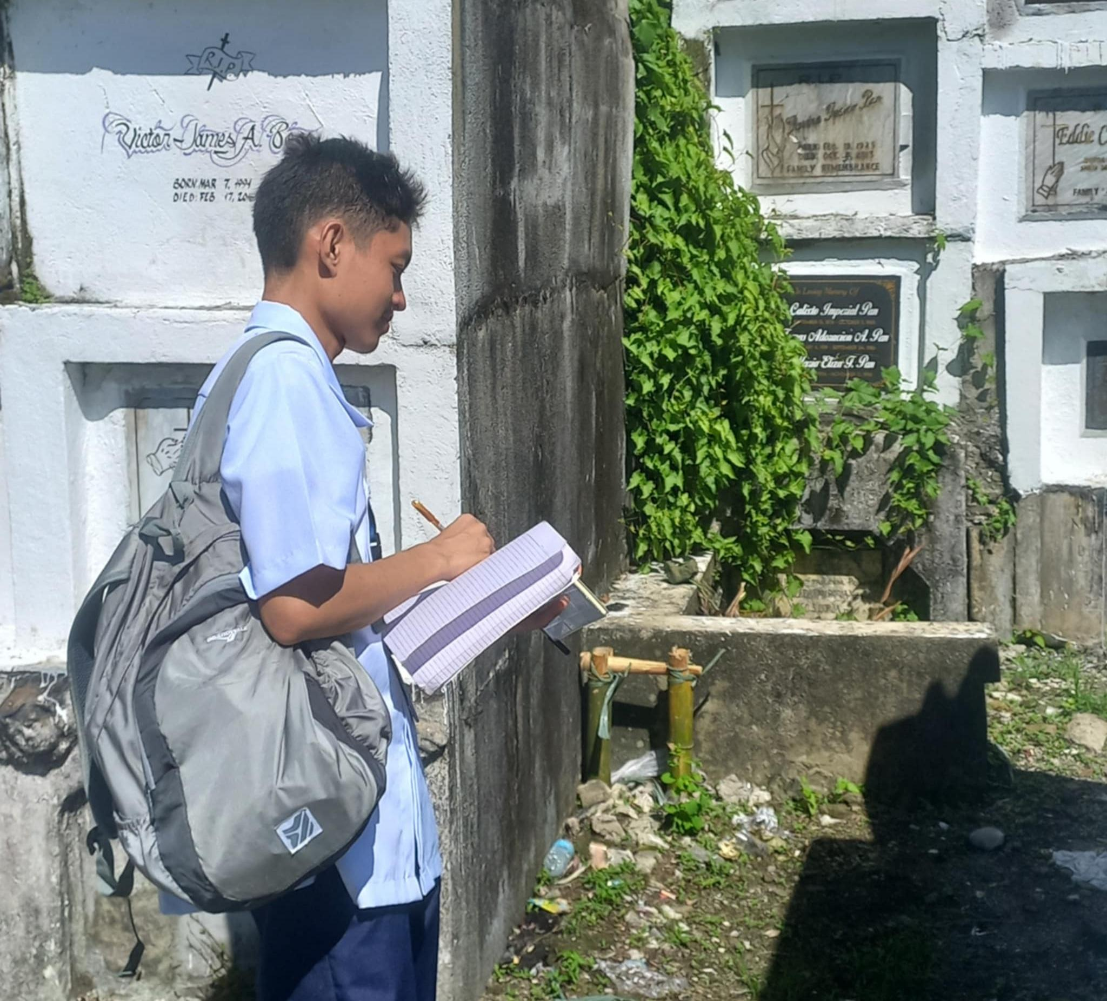 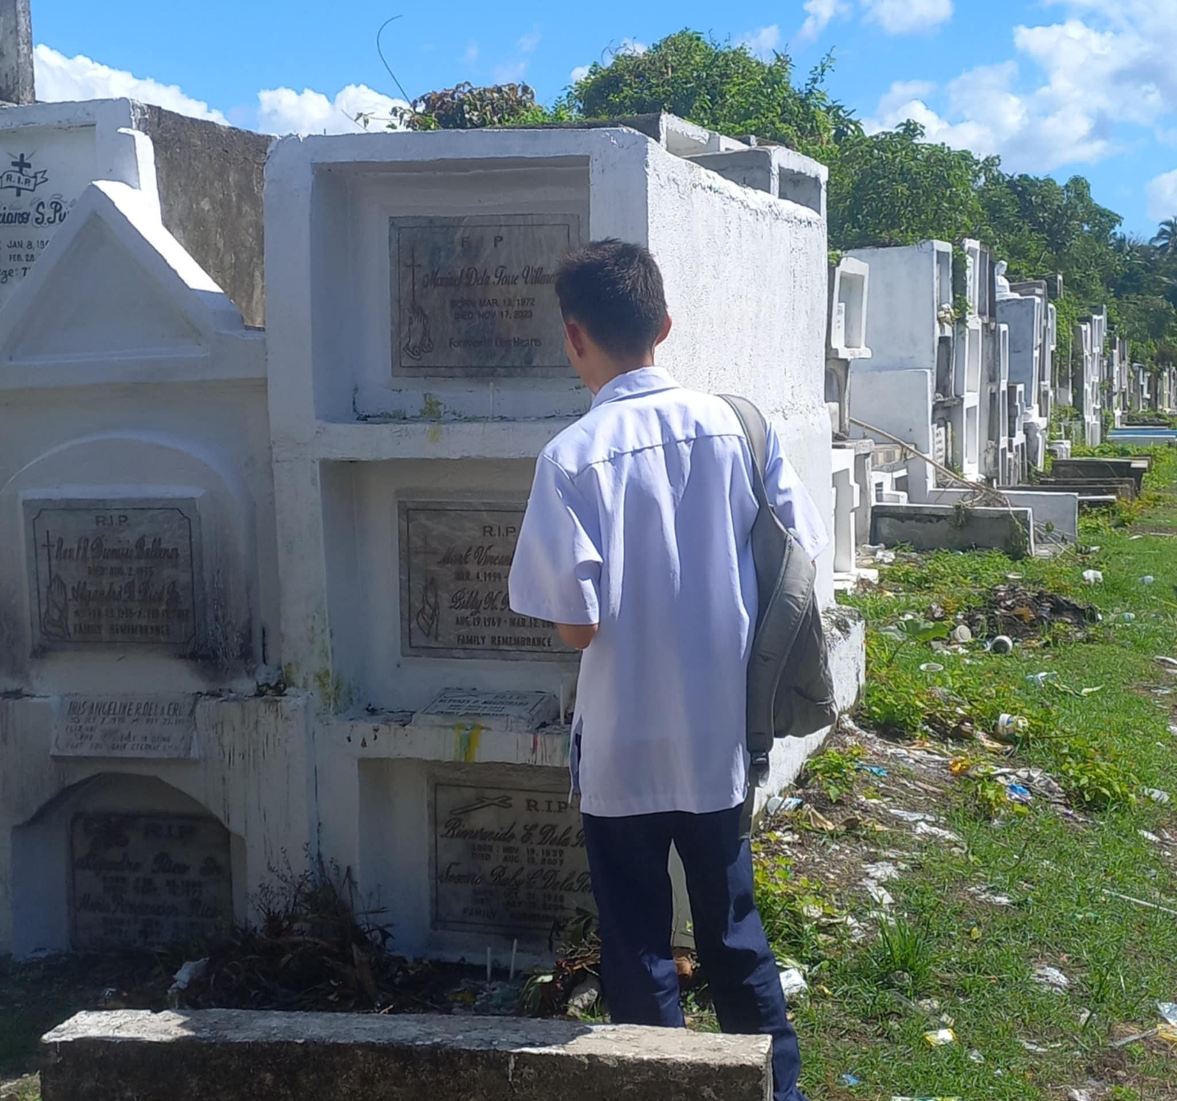 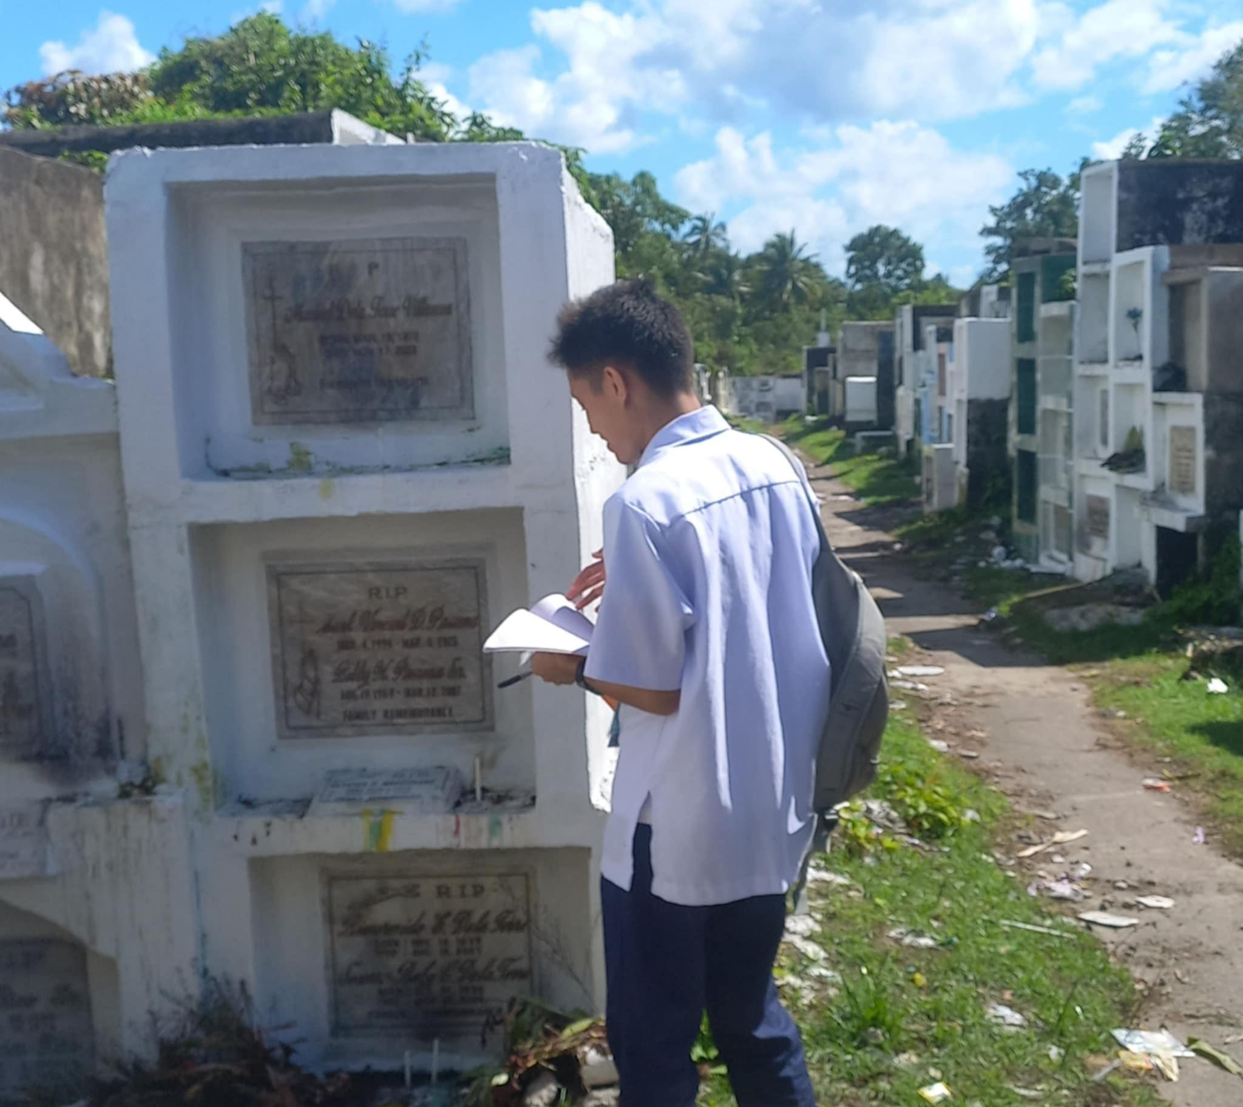

*[I've partially walked at the San Ramon, Iriga Cemetery during/after church mass. Then, gathering information about the investigation in Mabca, Sagñay cemetery. Finally, documentation of basic research on cemetery mapping for a picture here in San Benito St.,Goa cemetery Looks like I've been collecting data of the dead so far.]*

**IV. Experiences and Insights**

For the record, I am an accountant counting the peso for over a thousand. To be honest, I've never anticipated this and expect that I am counting the proportional age of the people who've been born on this day and passed away. It weighs my insights even more. What is valuable? Is it the money or the lives? How much does it cost to live accordingly? In my perspective, life is equivalent to more than a trillion tons of money. Plain simple, life is once in a lifetime not twice or thrice. Money can be replicated. Life is a risk. You'll never know if you never try for real. If I could measure the length of the day to live on and plan is an important tool to make life work easier.

The aftermath of the typhoon Kristine brought deaths in the Bicol Region. Which is, devastating news to be precise not just a calamity as far as concerned also the lives and livelihood of the affected areas. Pigs/pets are bloated, the crops are putrid, the documents are cockled. I've seen a video of the security personnel here in the dorm. This is such a lesson that resiliency is the best policy to have in life. The awareness of the people could also elongate the life of a citizen.

Life is an exquisite present to ever have. I mean, when you think about it sometimes you've experienced that we appreciate and complain that life is so unfair. Life is worth living. Life is not what it seems to be. Life is a balance, never give up and keep moving forward. So the purpose of our lives is to be happy. Sometimes, we insist on making it complicated. We're busy searching for a plan to make a reality, that we create our own world. Life teaches us a lesson and we must learn from it. We ask ourselves: Could we get a nice fulfilling life? I mean, that's life.

Death may seem scary. Nothing to be afraid of. Everyone meets their ends and the road always leads to death itself. If you stop then, be terrified all the time. Then, nothing happens. It is a limbo of cowardice and regrets. Enjoy the moment while it lasts. Because when it runs out of batteries, there is no light to see in the dark. Look, I've witnessed the worst-scenario cases right in front of my face. What could be worse. This teaches me to become even more brave, step out of my comfort zone. Indeed, it is hard to let go. Have the courage to fight for your goodness sake.

Behind the scene of the crime, I mean it looks like it. The cemetery makes me feel uncomfortable to go there. There's a memory of mine that makes me chills through my spine. It reminds me of the death strikes within like an invisible force or an entity. When I go there by myself. The filthy waste occurs during the day of the dead on their graves. This project gives me a unique yet weird feeling to remember the ones you've loved when they're still alive. My true purpose was to search for the sepulchre of my deceased aunt. Seems like she doesn't want to. She doesn't like pictures of getting stalked either.

Seeing a graveyard is a wild ride to venture. I am definitely trembling when I was in the middle of the cemetery. You know having a permission to take a picture is a certain action of talking to the spirits. Tons of graves placed through the other tomb. I wonder if there's catacombs therein. Bones were preserved through the ossuary in a memory of the departed person. It would be a nightmare if you were buried alive. All the mourning and grieving are held upon their arrival. You hoped that I could sigil my mouth but no. Let me through this, there are rumors about the scattered bones in that area which I don't even bother to see at all. Some old folks have this superstitious belief, by the way, I truly respect theirs. Do not put together your dish with others. Are you even happy to vigil? If so, elderly are not going to like that attitude. Never mock the late departed person, they are deemed to be in a vicinity of the area where they are buried. And so on.

Otherwise, they will be a consequence for disturbing someone's resting place. They say you can summon the dead back. You can visit a graveyard from nowhere and you can use the ouija board as furthermore as recommended. I wouldn't do that if I were you. That's why witches tend to consolidate as spiritual doctors. For me, it's just hocus pocus practice.

I've also had to get the wet ink impromptu by the treasurer of Sanguniaang Kabataan in an affair of myself as a secretary. The eerie vibes going upon the corrupted organization when the leader acts like a boss. I am truly not happy about that. The toxicity treatment is not healthy for a public relationship even. A barangay official, my friend, formerly a youth leader, hinted to me to run for such tempting responsibility. If I try to file a candidacy for the position I've desired to be a politician. Then, I would've outrun the other candidates. They would be dead. I'd learned some tactics of how to manipulate the people in a best and efficient way without maligning the reputation of others. Sometimes, privacy is better than publicity. I don't want to please anyone or prove them that they're wrong. It's just I just want to adapt and make sure no one else could ever notice the surveillance cameras ever would've tracked me or else I'll be dead.

The truth is, I am not afraid of the dead. I am terrified of the living person whose objective is to pretend that they're true. They are only there for you just to suck out the blood sugar out of your clogged nose. Humans are unpredictable. So do I. Sometimes, I don't even know myself anymore. Passing seems to make you feel like you cannot pass the situation. Know that it's not the end of the world. Keep moving forward.